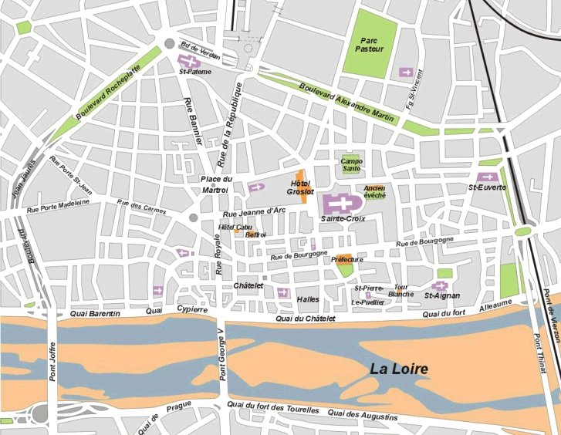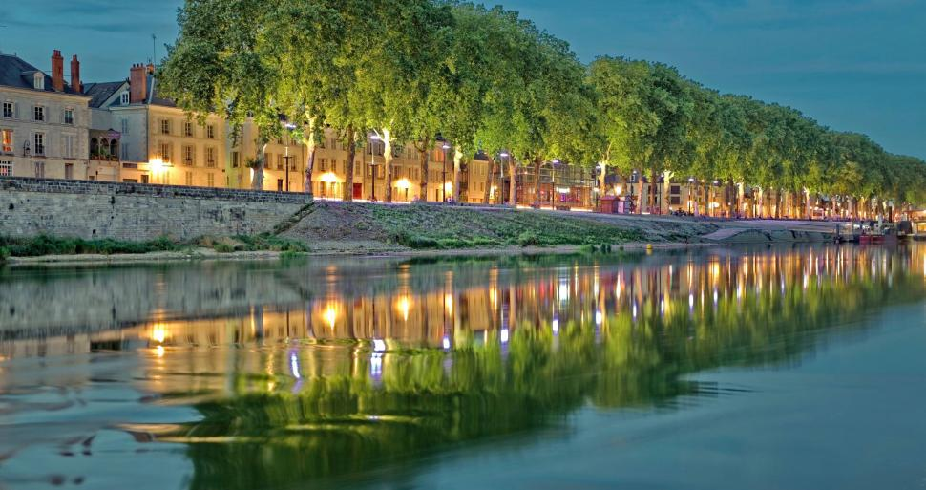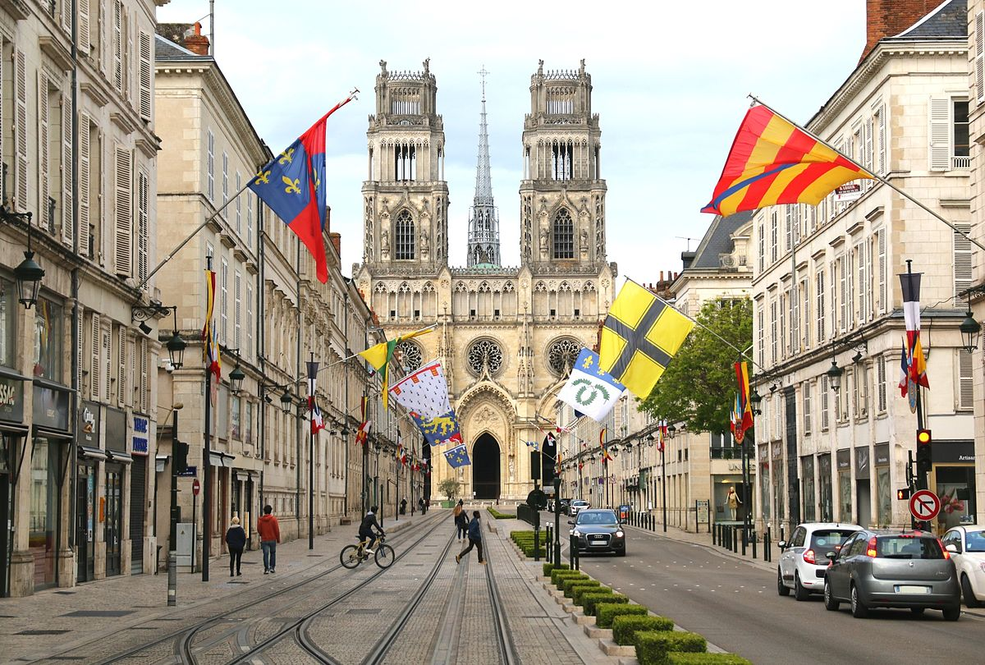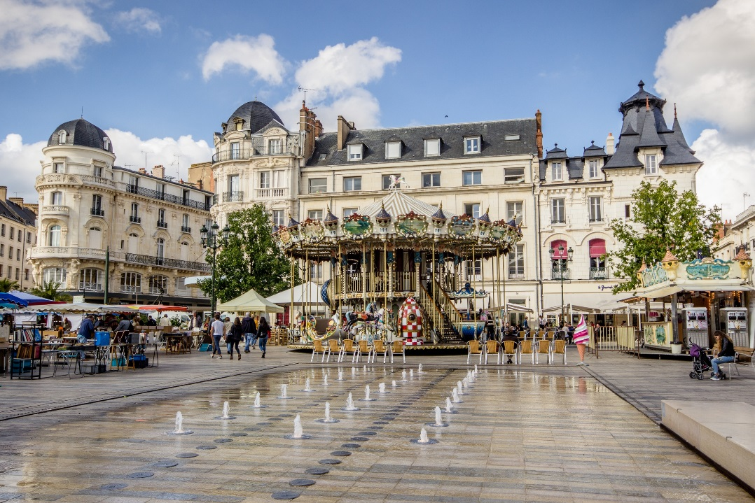

**1- Cathedral**

**2- The Hotel Groslot**

**3- Place of Martroi**

**4- The house of Joan of Arc**

**5- Bourgogne Street**

**6-The Loire River Bank**

**7-The place of Loire**







**6**

**3**

**4**

**5**



**2**



**1**



**7**



Monuments accessible to disabled persons

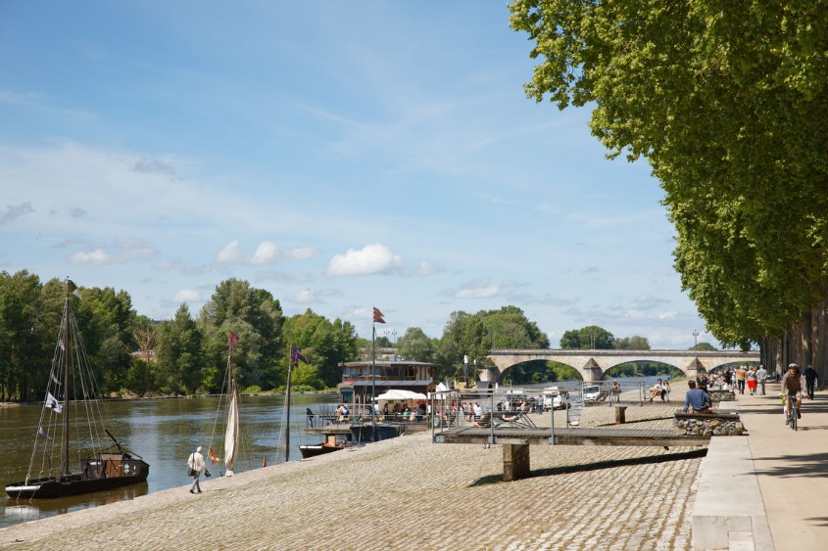

mo

|  |  |  |  |  |
| --- | --- | --- | --- | --- |
|  |  |  |  |  |
| Cathedral |  |  |  | **✓** |
| The Hotel Groslot | **✓** |  |  | **✓** |
| Place of Martroi | **✓** | **✓** | **✓** | **✓** |
| The house of Joan of Arc |  |  |  |  |
| Bourgogne street | **✓** | **✓** | **✓** |  |
| The Loire River Bank | **✓** | **✓** | **✓** |  |